HOW TO SETUP THE CONTINUOUS INTEGRATION AND CONTINUOUS DEPLOYMENT FOR .NET APPLICATION

- Before setting up the CI/CD we need to bring the code from the GitHub to Azure Repos because azure DevOps requires access to the source code to build,test and deploy so having code in the azure Repos makes it easy to trigger pipelines automatically when changes are made.

- Method 1 :Import GitHub Repository directly into the Azure Repos:

This method is useful If you want to repos the code from GitHub to directly into the azure Repos

Step 1: Go to Azure DevOps and Open your project.
Step 2: Click on the Repos and Click on the Import Button.
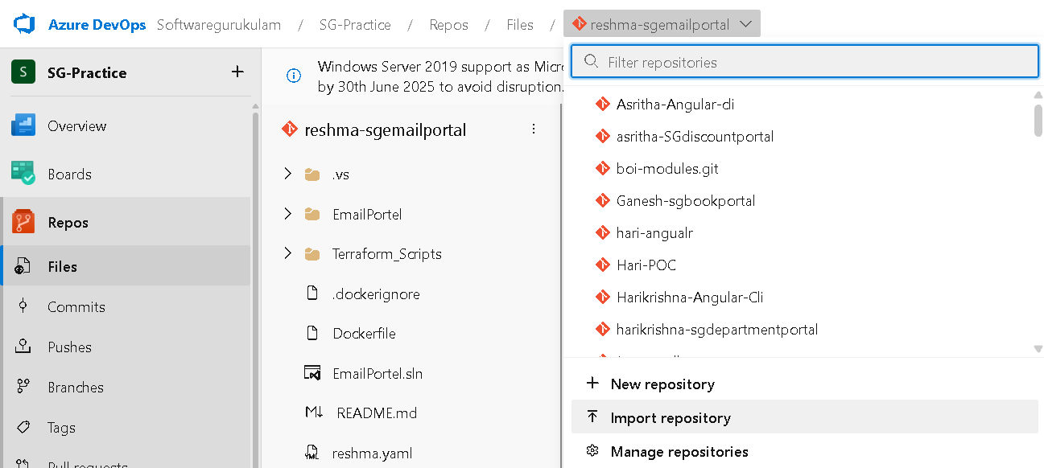

Step 3: In the Import,we have a GitHub URL so we need to paste your github repository URL and then Import it.
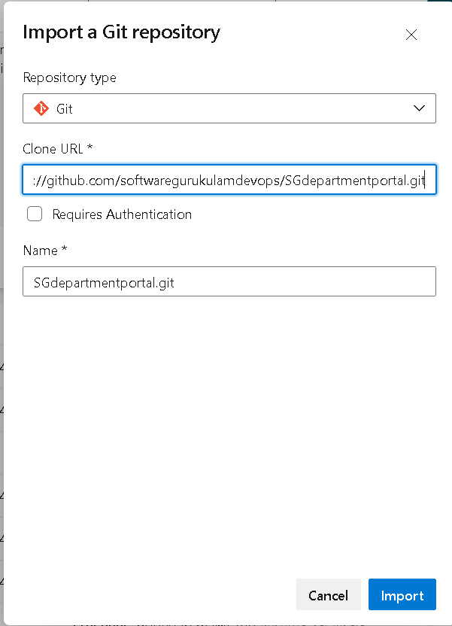

Azure DevOps will create a new Git repo and copy all the code from GitHub.

- Method 2 :Clone to Local and Push to Azure Repos:

This method is for when you have code locally (Or cloned from GitHub) and want to push it manually to Azure DevOps.

Step 1 : Create an Empty Repo in the Azure DevOps -->Azure DevOps --> project-- ->Repos-->New Repository

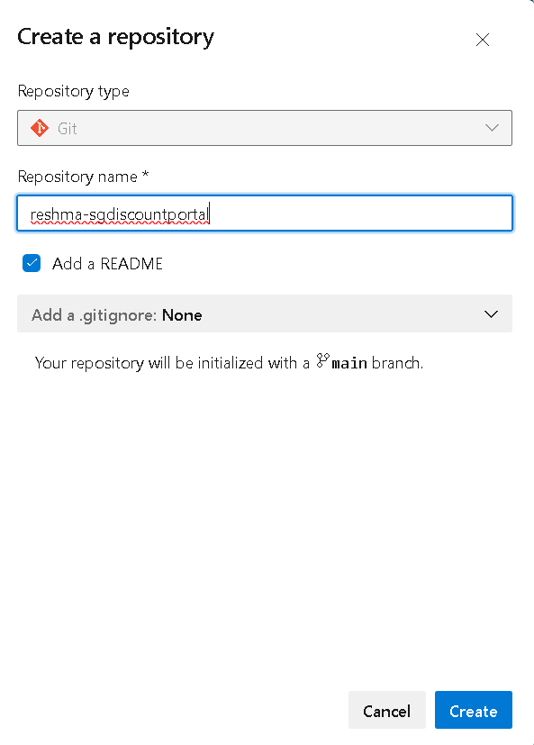

Step 2: Copy the github repo and git clone it in the local,it makes a local copy of the repository in our computer.

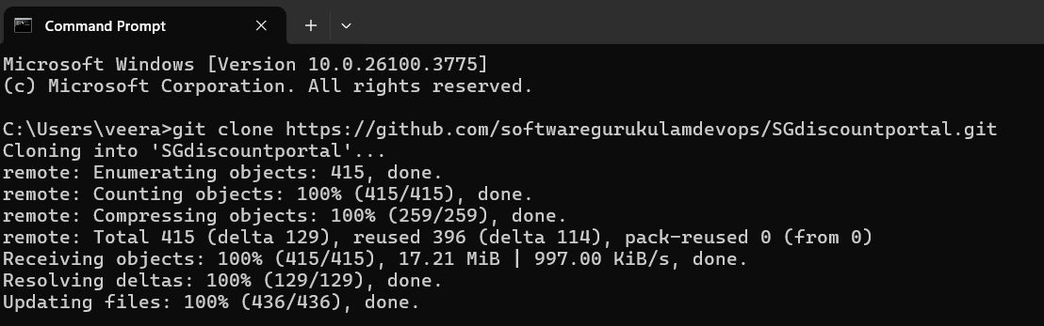

Step 3:
- Naviagte into the project directory cd project-name
- copy the azure repos url and use the command git remote add azure <link URL>
- Push the code into the main branch-->git push azure main
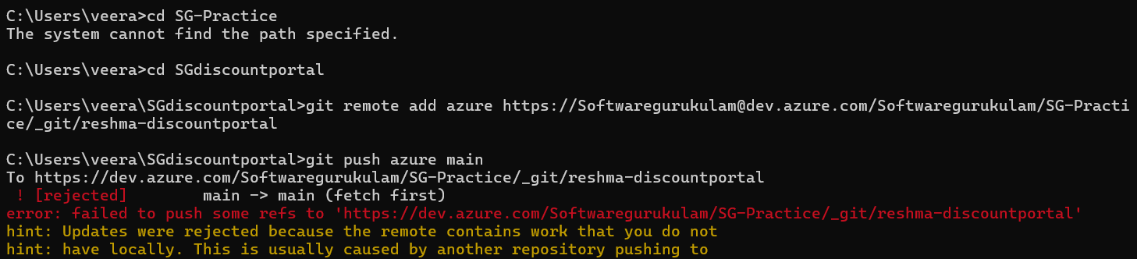

Step 4:
- When we want to push the code into the main branch it shows the error because we can’t access it so we need to do pull request
- So,for pull request we need to push the code into new branch and create a pull request to merge with the main branch.
- Create a new branch final and push the code into it-->git checkout -b final
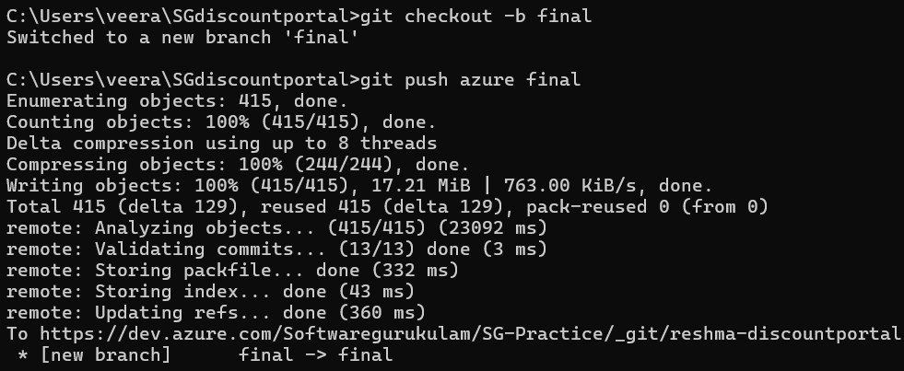

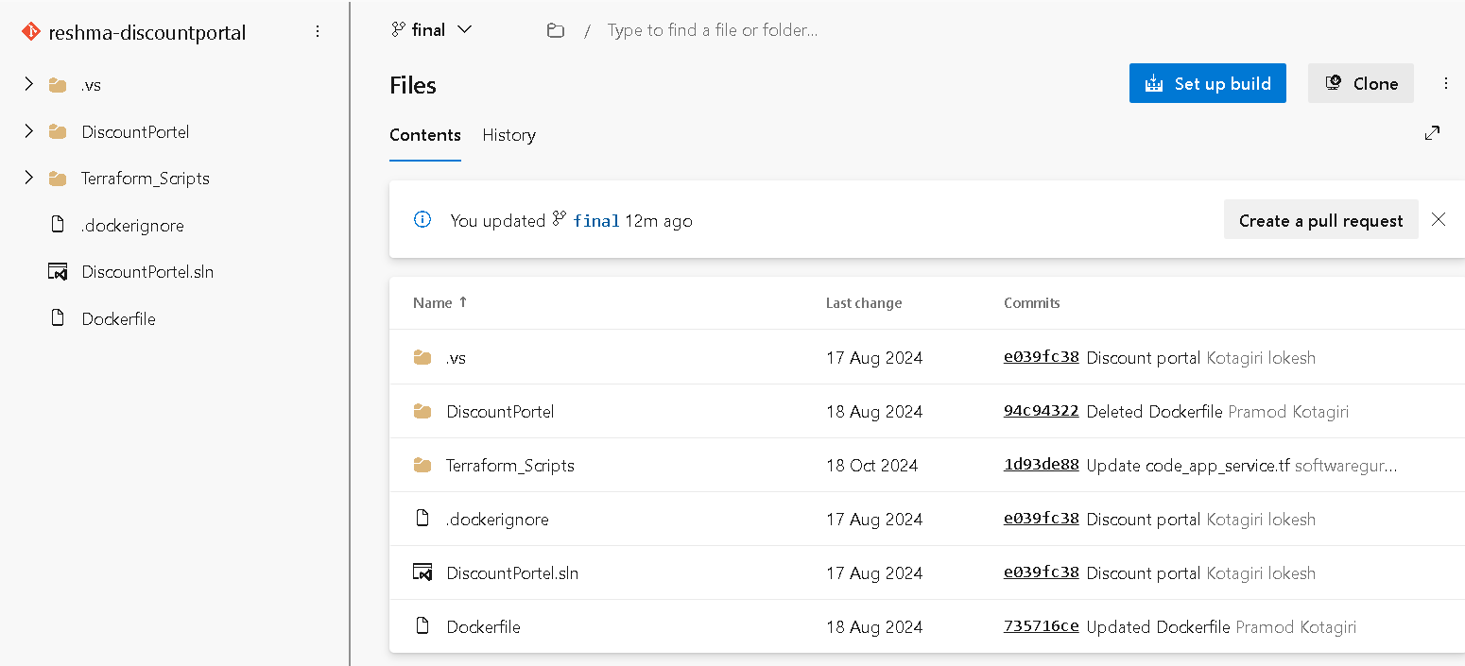

- So,we push the code into the final branch and now create a pull request so we need to get the approval so then it merge with the main branch.

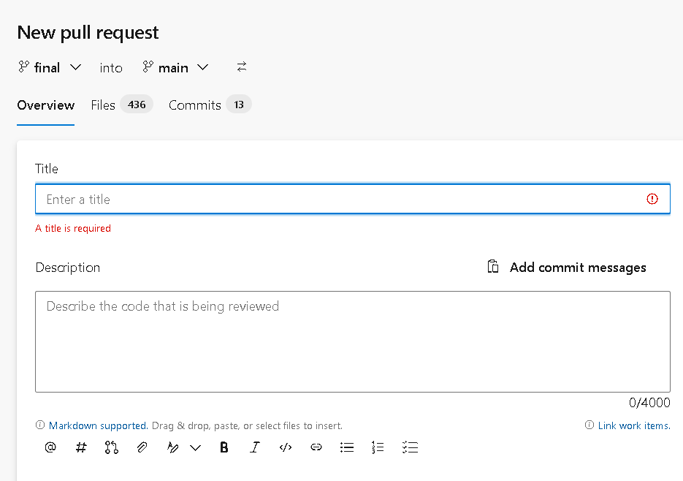

This is how we repos the code from github to azure devops with 2 methods.

- Before setting up the CI/CD,what are the editors we use in the pipelines.
- Azure DevOps provides two ways to create and configure pipelines:

1.Classic Editor
The Classic Editor provides a visual, drag-and-drop interface to build your pipeline without writing YAML.
- Tasks are added step-by-step through a GUI.
- Great for beginners or users who prefer not to write pipeline code.
- You can still customize each task with inputs and parameters.
- Best for: Users new to Azure DevOps or those who prefer a no-code / low-code setup.

2.YAML Editor
The YAML editor allows you to define the entire pipeline as code using a .yml file. This method is popular in modern DevOps because:
- It's stored inside the repository, which means version control is built-in.
- It's portable and easy to reuse across projects.
- Ideal for advanced users who want flexibility and full control.
- Understanding the Build Process Before CI/CD:
Before setting up CI/CD, it's important to understand how a .NET application's build process works:
- Developers typically write code using Visual Studio or VS Code.
- To build the code, tools like MSBuild (Microsoft Build Engine) or Visual Studio Build Tools are used.
- The .sln (solution) file is a key file that holds the structure and dependencies of the application. Build tools use this file to know how to compile the entire solution.
Build Process Steps:
- Compilation – Source code (.cs files) is compiled into intermediate language (IL).
- Linking – Dependencies are linked to create a complete application.
- Packaging – Output files like .dll (Dynamic Link Library) or .exe are generated.
- These output files are stored in folders such as:
- /bin/Debug or /bin/Release
- The generated output, also known as build artifacts, is what gets passed to the deployment stage in a CI/CD pipeline.

What is CI (Continuous Integration)?
Continuous Integration (CI) is a software development practice where developers regularly push their code changes to a shared repository (like Azure Repos or GitHub). Every time code is pushed, an automated pipeline is triggered to:
- Build the application
- Run tests
- Generate artifacts
The main goals of CI are to:
- Detect errors early in the development process
- Ensure that new changes do not break existing code
- Maintain a consistent, working version of the application at all times
In Azure DevOps, CI pipelines help automate this process so that you don’t have to manually build or test the application every time there’s a change.

- Setting Up CI for a .NET Application in Azure DevOps using Classic Editor:
- Create a Continuous Integration (CI) pipeline in Azure DevOps for a .NET application using the Classic Editor.

Step 1: Prepare Your Code in Azure Repos
- Go to https://dev.azure.com and open your project.
- Push your .NET source code (with .sln and .csproj files) to Azure Repos.
- Ensure the code is in a specific branch (e.g., main).
Step 2: Create a New Pipeline with Classic Editor
- Navigate to Pipelines
- Click New Pipeline.
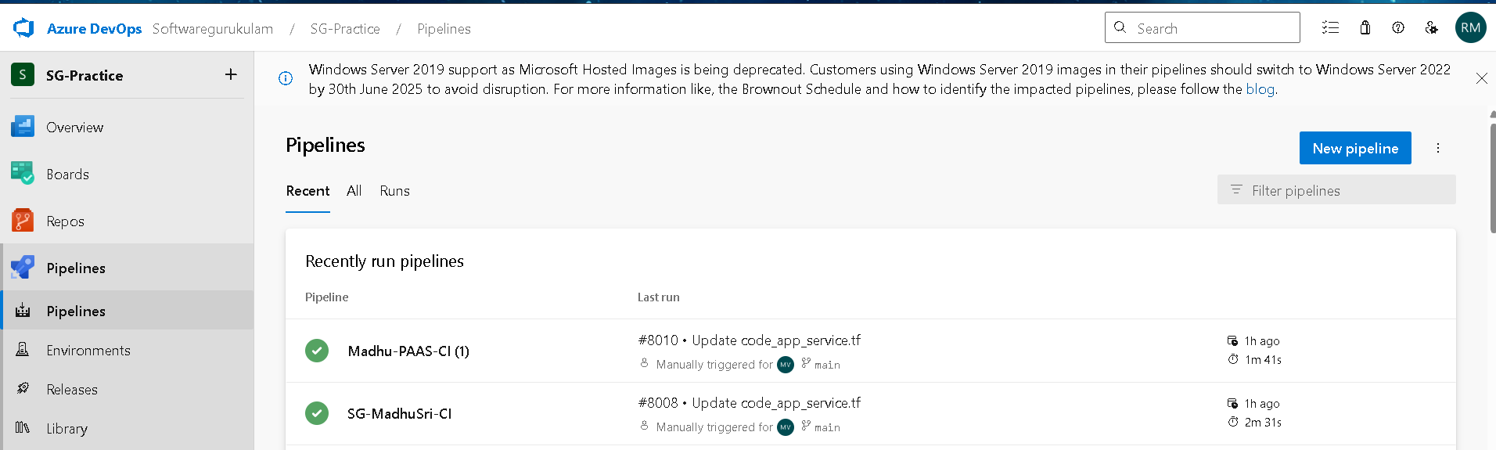
- Click "Use the Classic Editor" link at the bottom.
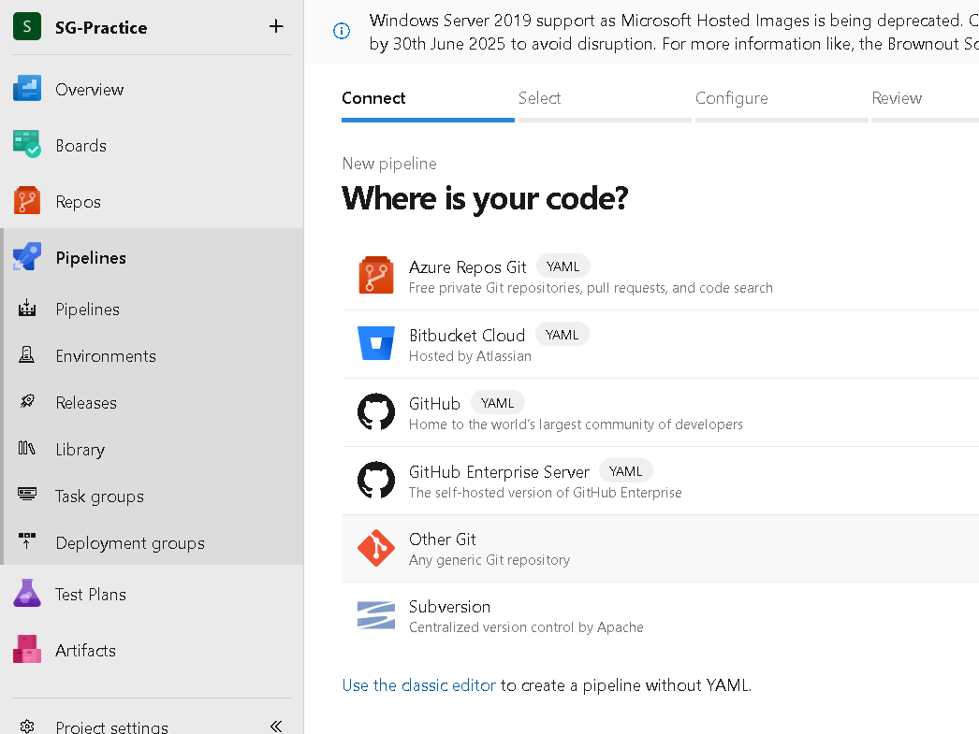
- Select:
- Your Azure Repos Git repository
- Your working branch (e.g., main)
- Click Continue
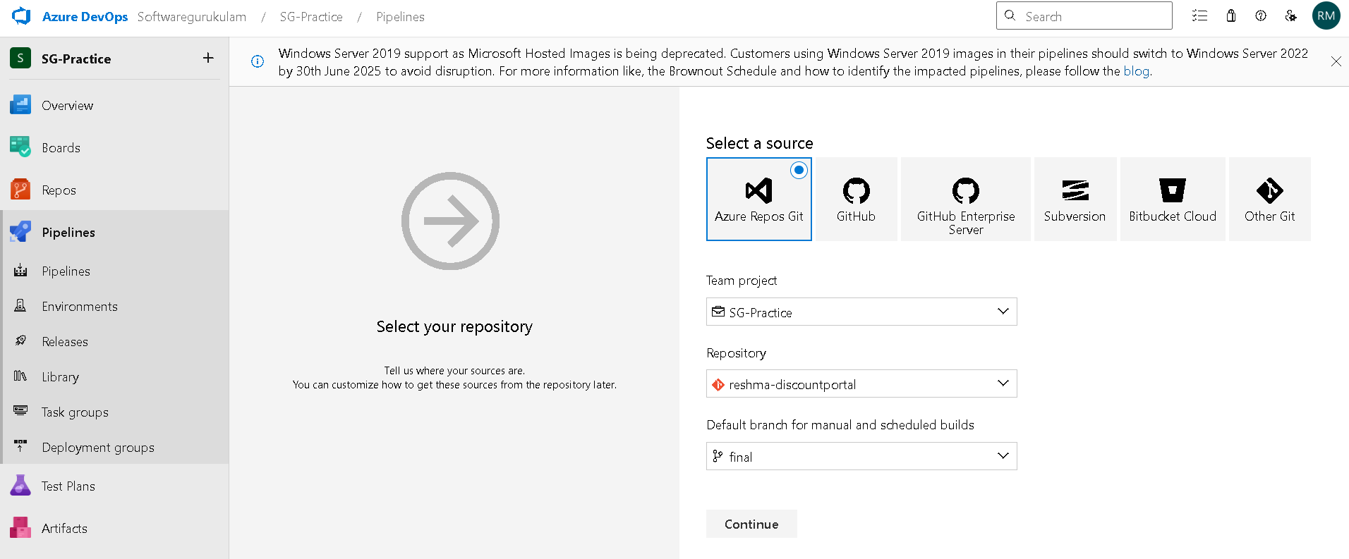

Step 3: Choose a Template or Start with Empty Job
- Choose Empty Job for full control or select a .NET template.
- Click Apply.
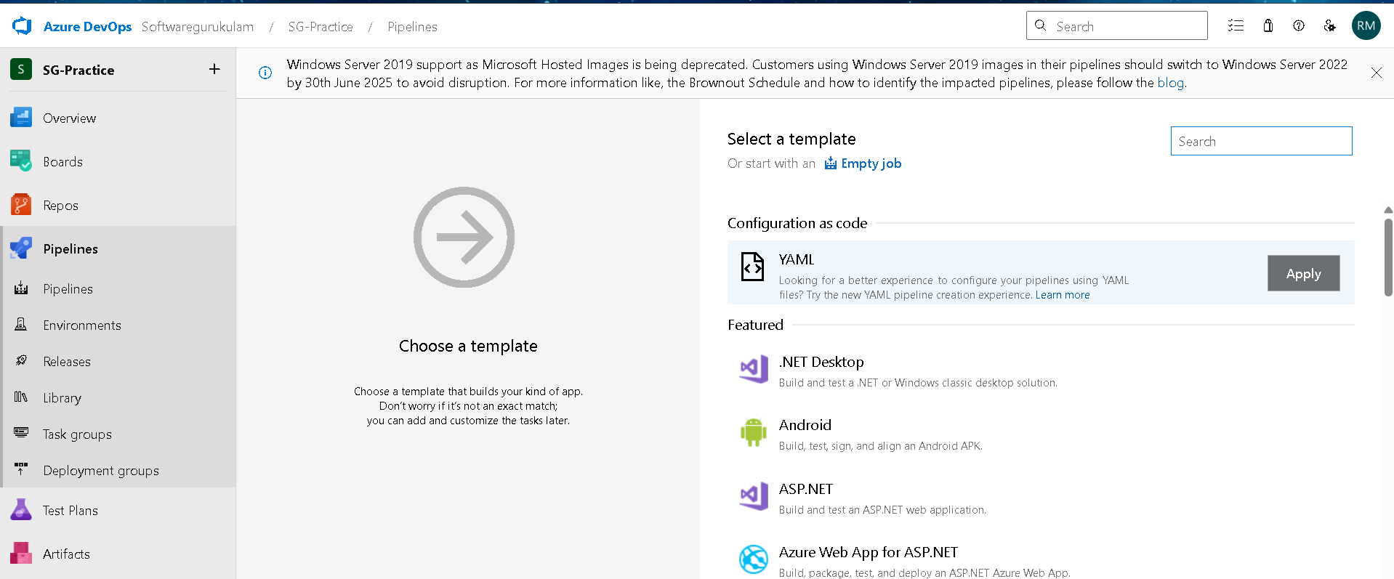
Step 4:
- Select the agent pool
- Select the agent specification.
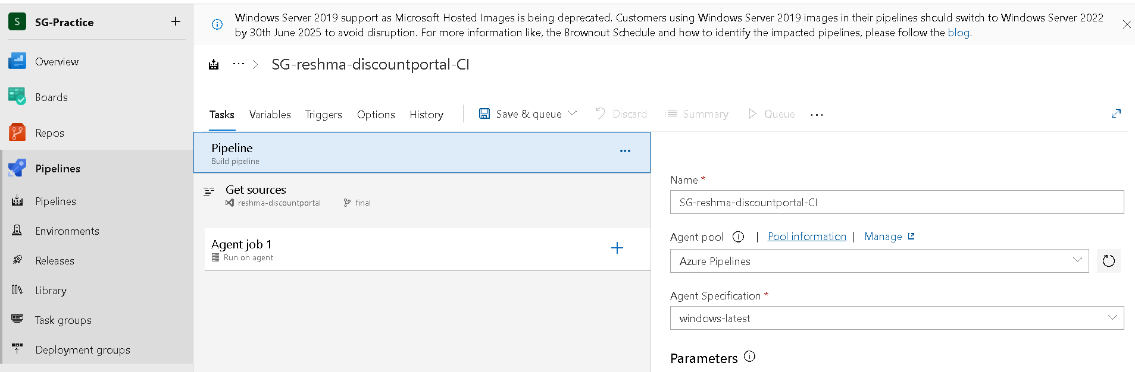
- Check your repository and branch
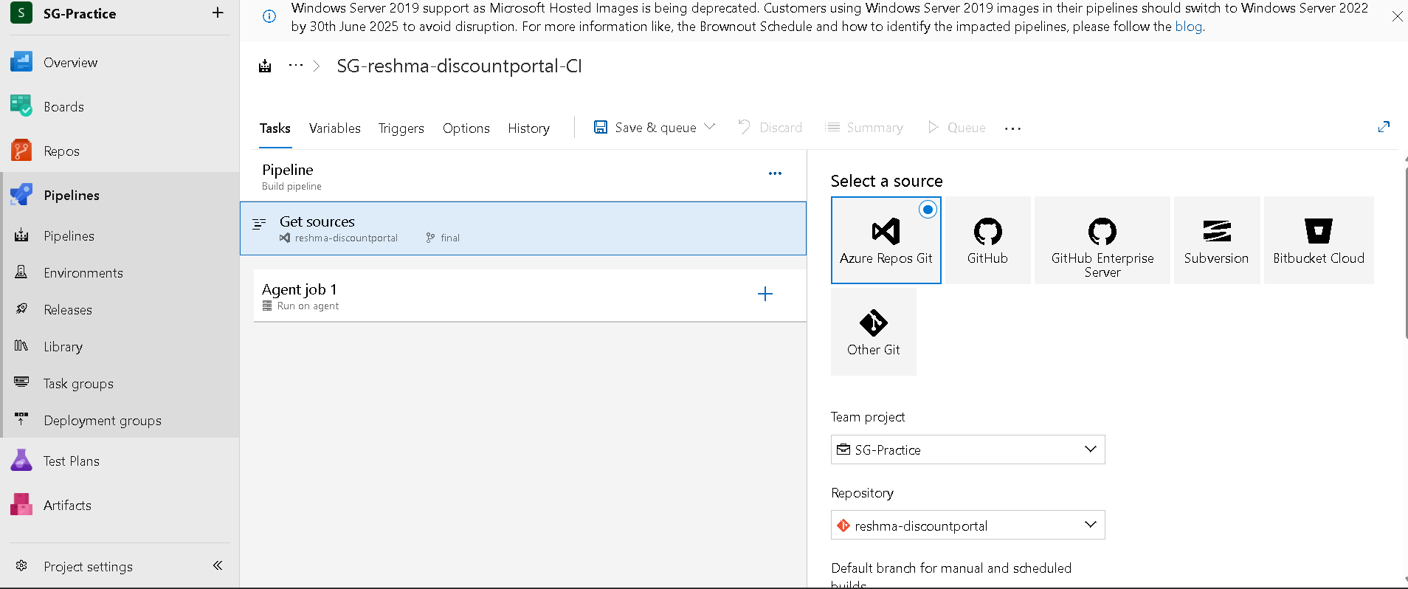
Step 5:
- Here the process is run on agent.
- Select the agent pool and specification.
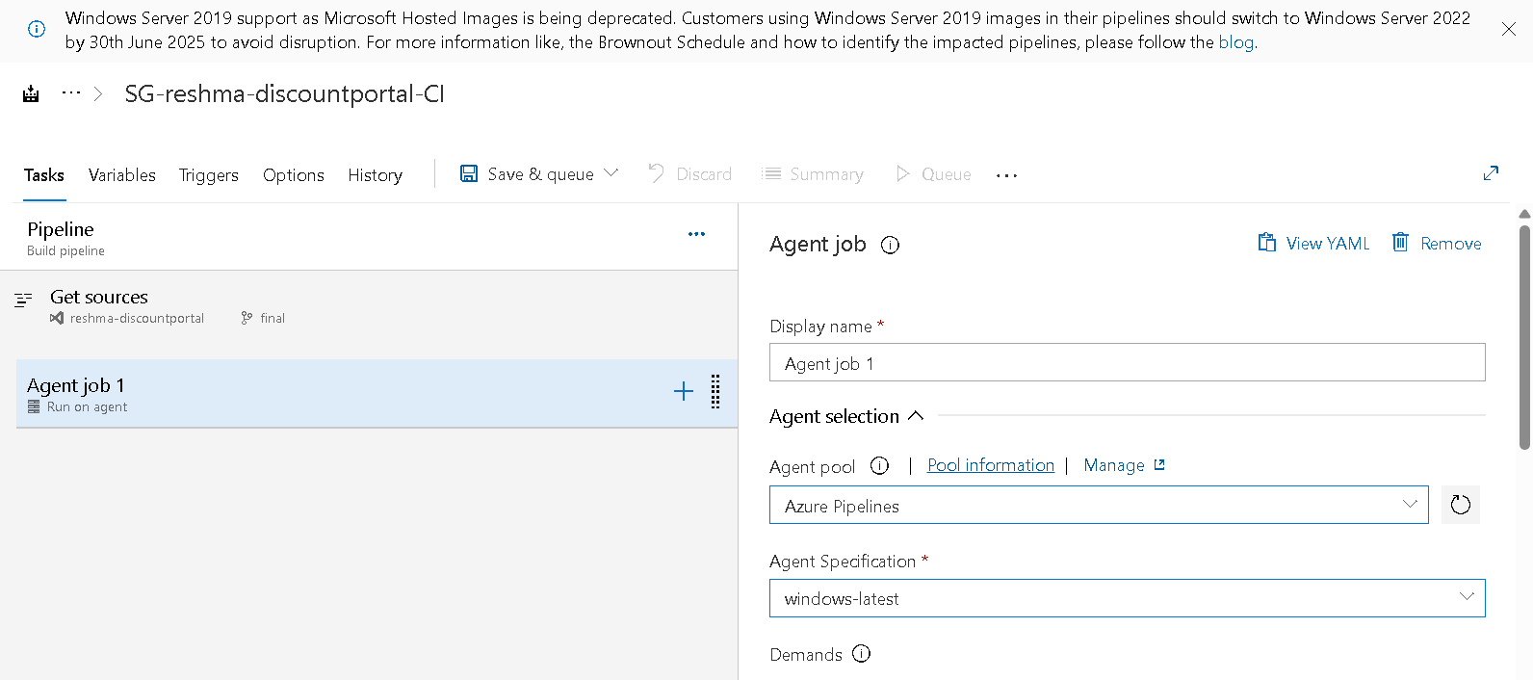

Step 6: Select the tasks to the .Net Application by clicking on ‘+’ symbol.

- Task 1: NuGet Tool Installer:

Purpose: Sets up the required version of the .NET SDK on the build agent.

- Add NuGet tool installer.
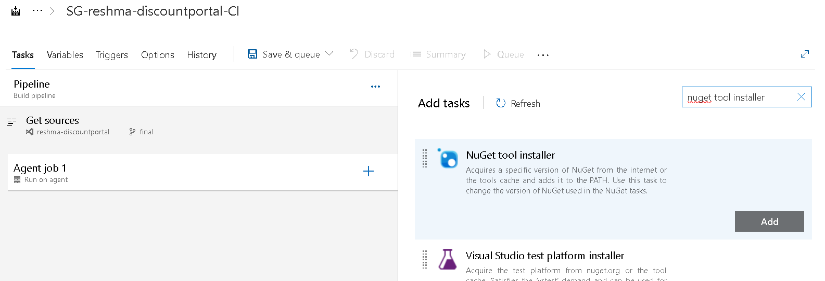

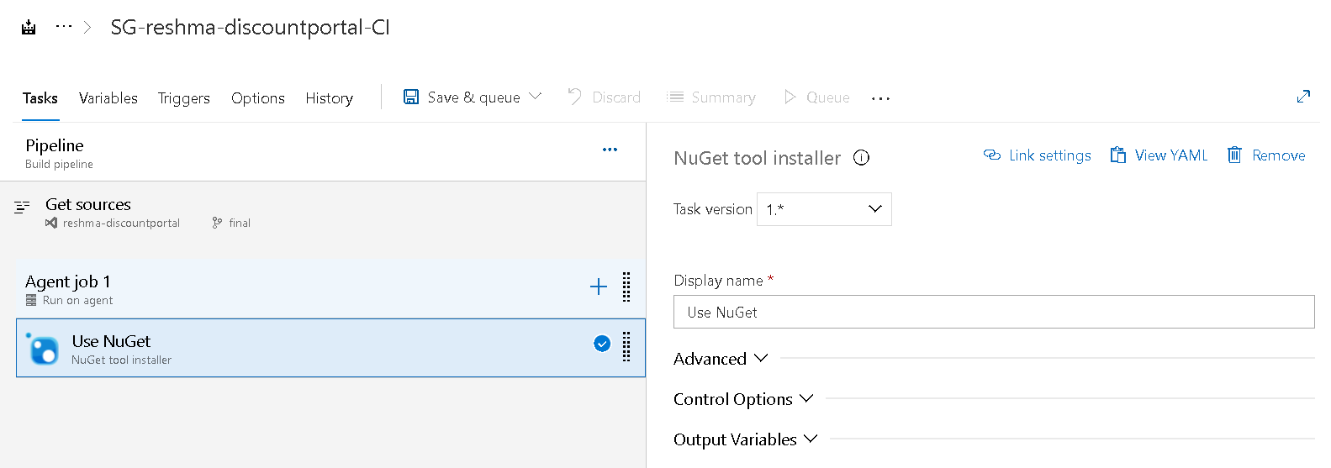

- Task 2: NuGet Restore:
Purpose: Downloads all the dependencies required by your application (defined in the .csproj file).Why It Matters: Without this, your build will fail due to missing libraries or packages.
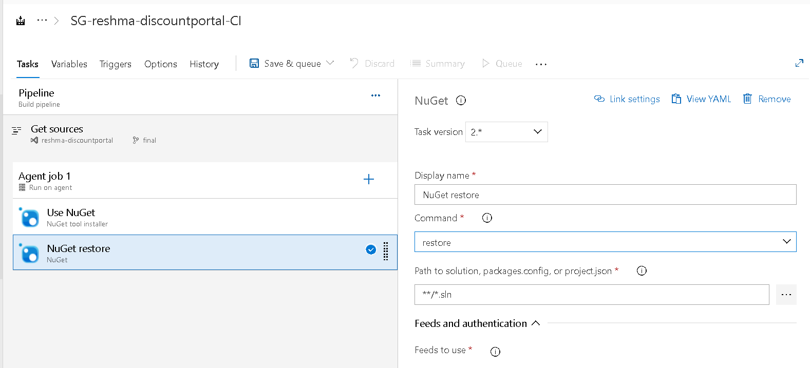
- Task 3: Ms Build:

Purpose: Compiles the source code into DLLs or executables.

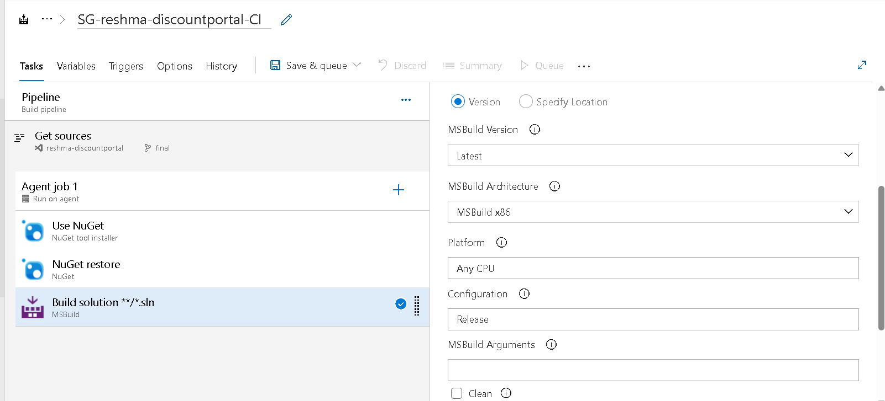

Using Variables for Platform and Configuration
- You can predefine values such as platform and configuration using Variables.
- Click on the Variables tab in the pipeline editor.
- Add variables like:
- Name: buildPlatform, Value: Any CPU
- Name: buildConfiguration, Value: Release
- You can then reference these in tasks using syntax like: $(buildPlatform) or $(buildConfiguration).
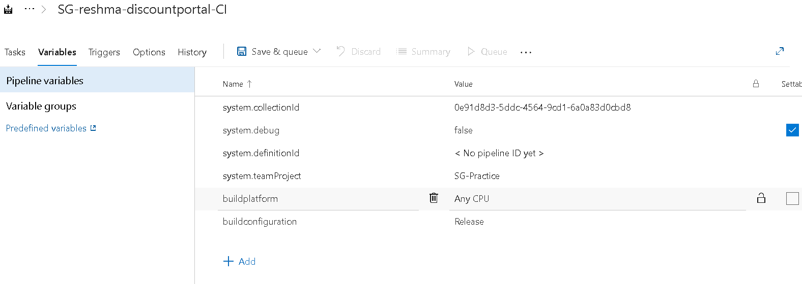
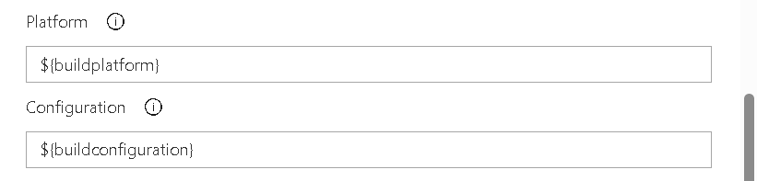
- Task 4: Copy files:
- Configure:
- Source Folder: $(Build.ArtifactStagingDirectory) or $(Build.SourcesDirectory)/bin/Release
- Contents: **/ (or filter like *.dll,*.tf, *.exe, etc.)
- Target Folder: $(Build.ArtifactStagingDirectory)/copied
- This task is useful if you want to reorganize files or collect specific outputs before publishing them as artifacts.
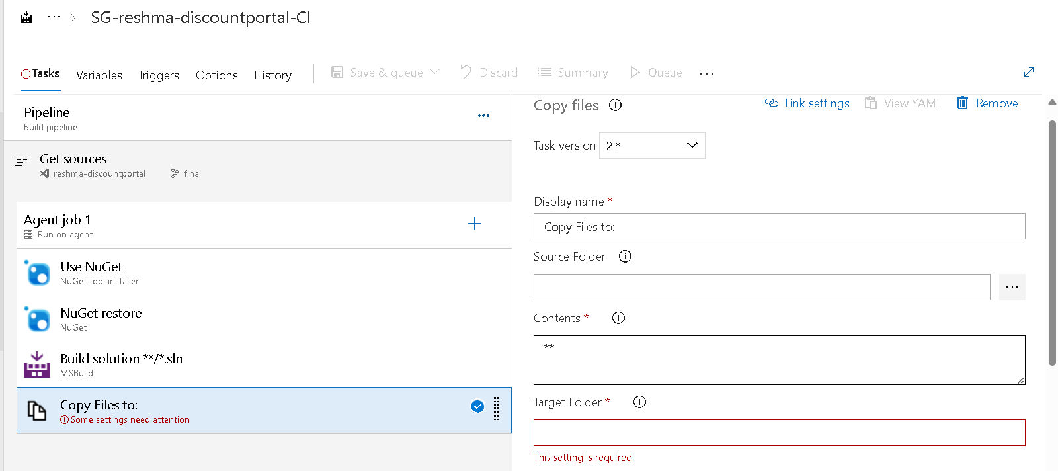
- Task 5:Publish Build Artifacts:
- Purpose: Uploads the published output (DLLs, config files, etc.) as a build artifact.
- Why It Matters: Artifacts are required by the CD (Continuous Deployment) pipeline for releasing to environments like dev, staging, or production.
- If we disable the artifacts we can’t see the artifacts and we can’t download them.
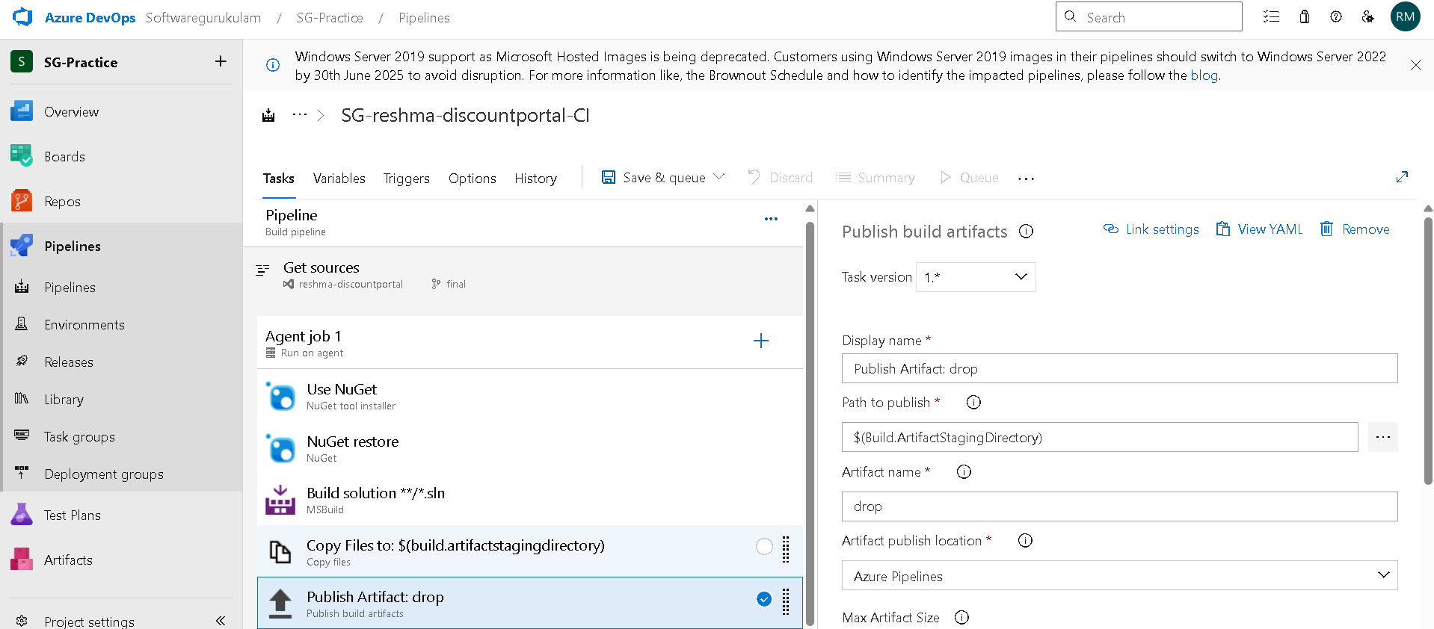

Step 7: Save and Run
- Click Save & Queue > Save.
- Click Run to start the first manual build
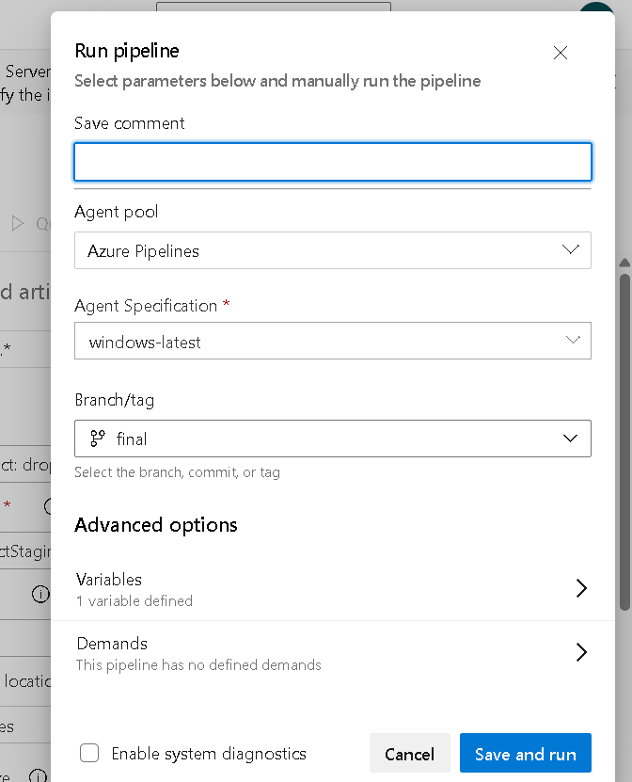
- a hosted agent is a virtual machine provided by Microsoft to run your CI/CD pipelines. You don't need to set up or maintain it — Azure DevOps will automatically create and manage it when your pipeline runs.
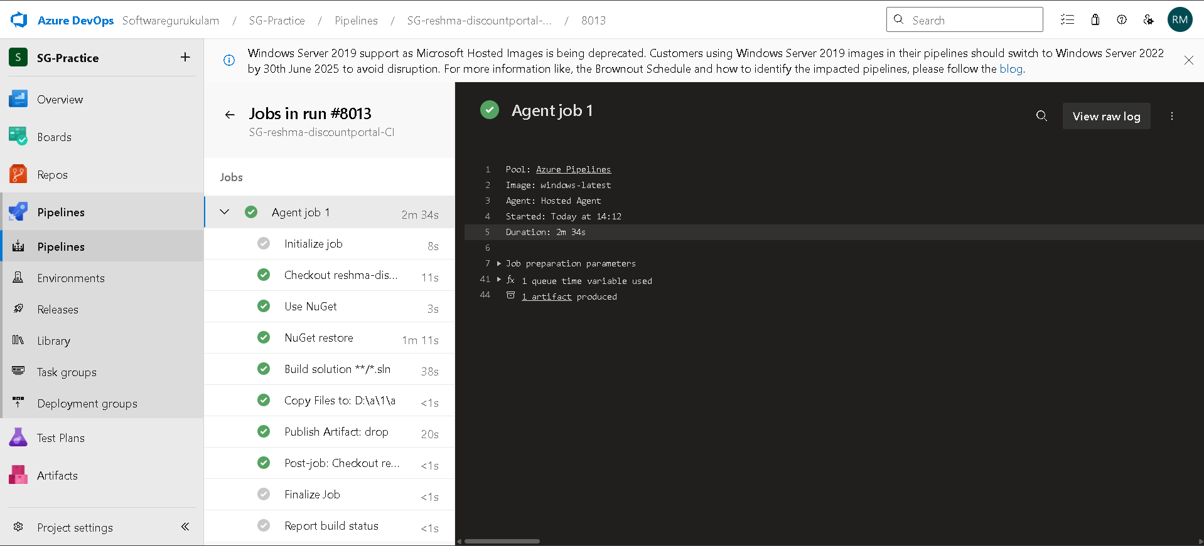

- This are the artifacts that are stored in bin folder.

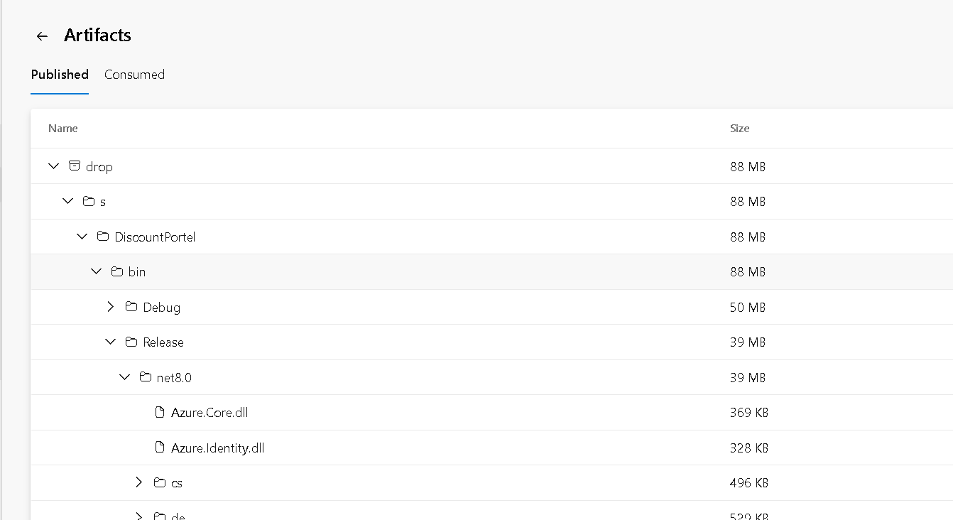

- Successfully build our pipeline SG-reshma-discountportal-CI

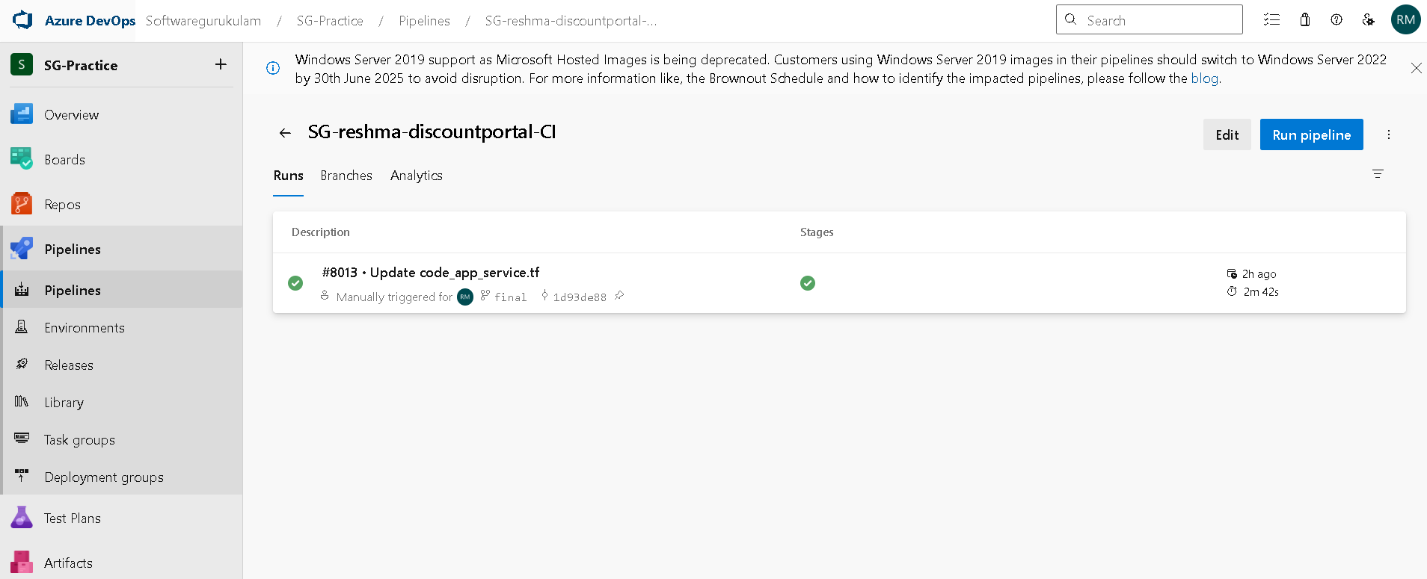

Continuous Deployment(CD) for .NET Application

What is CD?
Continuous Deployment (CD) is the automated process of deploying the application after a successful build. Once the CI pipeline produces build artifacts, CD takes those and deploys them to target environments like testing, staging, or production.

Types of Deployment Targets

IaaS – Infrastructure as a Service
- Deploy to Virtual Machines (e.g., Azure VMs or local VMs)
- Requires configuration of IIS (Internet Information Services)
- Needs a Deployment Group and agent setup for connection
- We need to establish connection between the azure devops and VM using deployment group.

PaaS – Platform as a Service
- Deploy to Azure App Service
- No infrastructure management required
- Direct deployment using Azure App Service Deploy task
- We need to establish connection between the azure devops to any cloud provider.

How to Deploy to IaaS using Deployment Groups (Local VM)

What is a Deployment Group?
A Deployment Group is a collection of target machines (like VMs) where you want to deploy your application. Each machine has an agent installed that communicates with Azure DevOps.

Steps to Set Up:
- Create Deployment Group:
- Go to Pipelines > Deployment Groups
- Click Add deployment group and give it a name (e.g., LocalIISGroup)

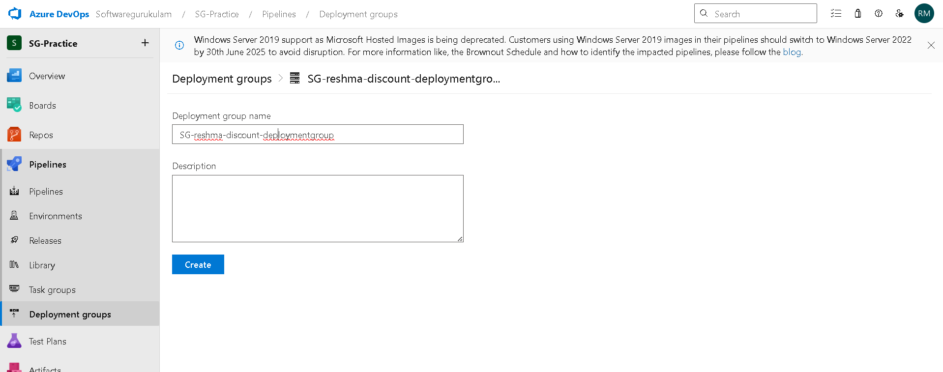
- Copy the registration script shown by Azure DevOps.
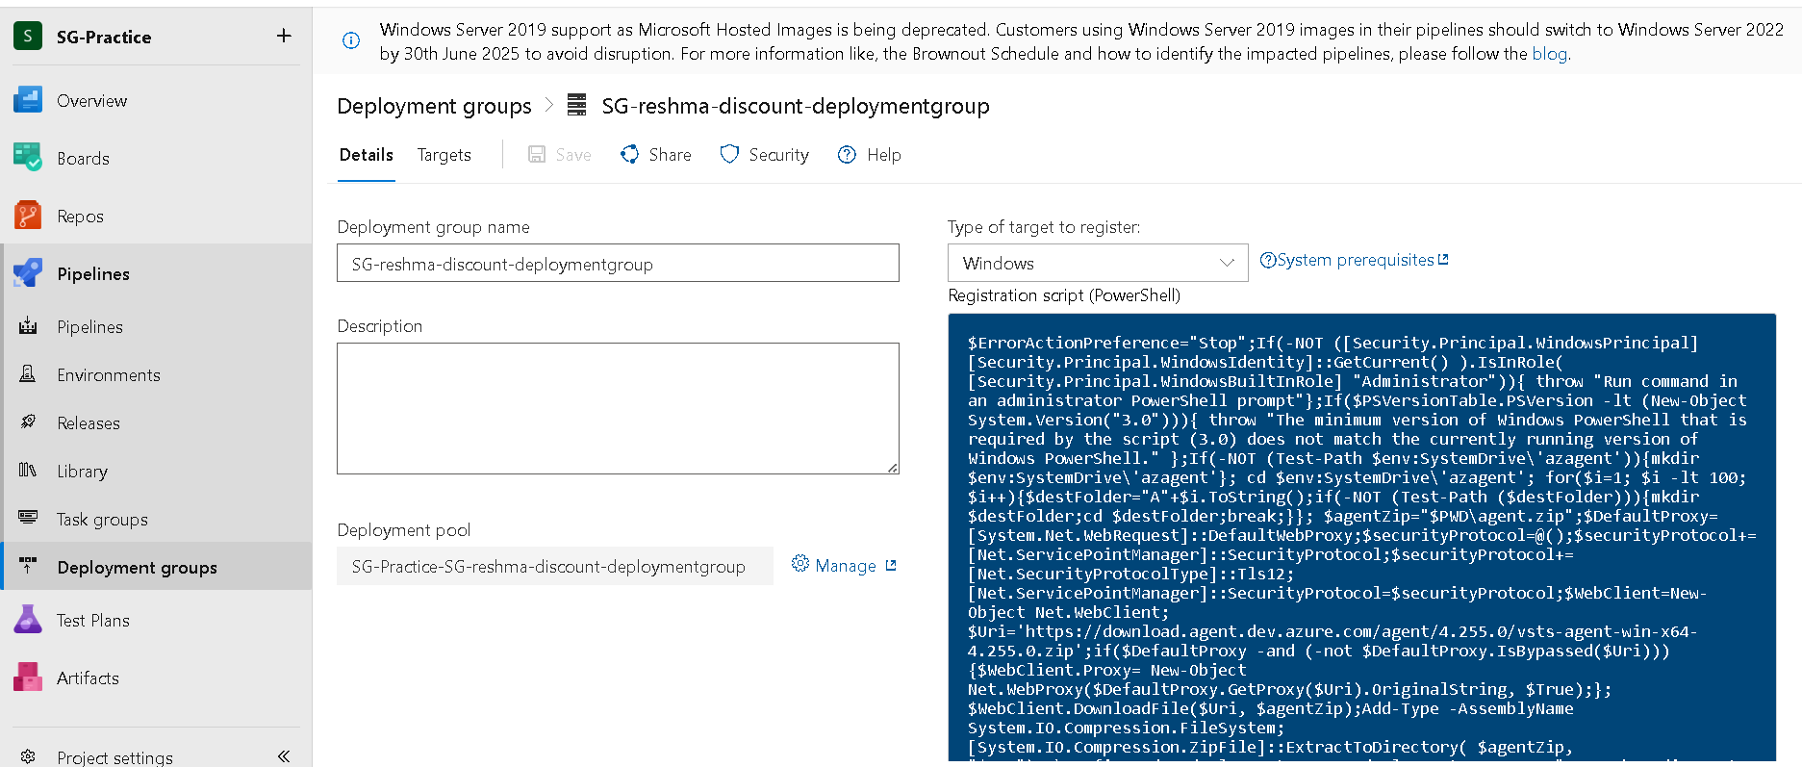

- Run Script on VM:
- Open PowerShell as Administrator on your local VM
- Paste and run the script
- This installs the agent and connects your machine to the Deployment Group.
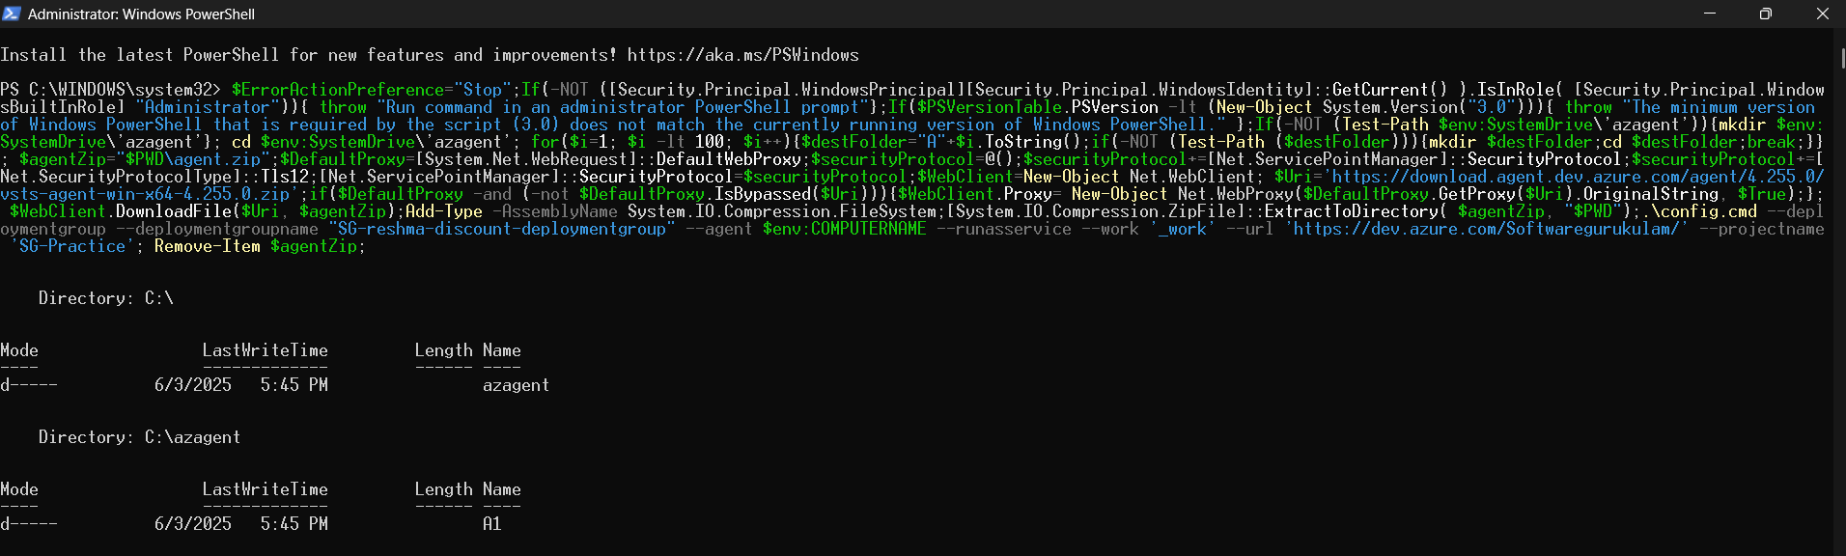
Verify Connection:
In Azure DevOps, your machine should appear as Online in the Deployment Group
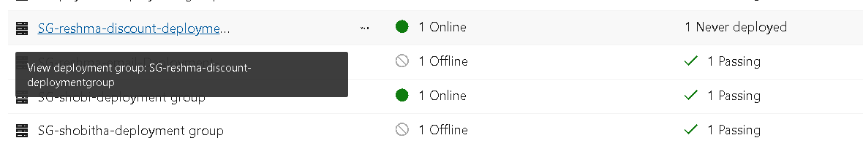
- Install IIS on the VM:
- Open Control Panel > Programs > Turn Windows features on or off
- Enable Internet Information Services (IIS)
- Make sure Default Web Site is running

- Create a release:

Step 1:Build Pipeline Creates Artifacts
- Your CI pipeline compiles the .NET application and produces a build artifact (like .zip or .dll files).
- These artifacts are published to Azure DevOps as outputs, ready to be used for deployment.
Step 2: Create a new release pipeline.
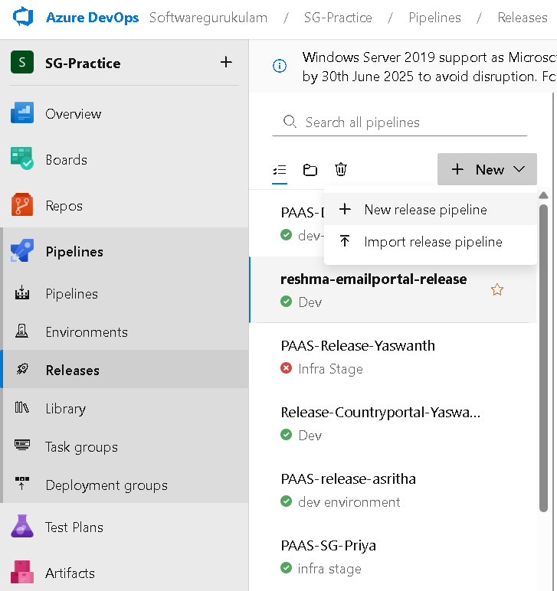

Step 3:
- Add your Artifacts

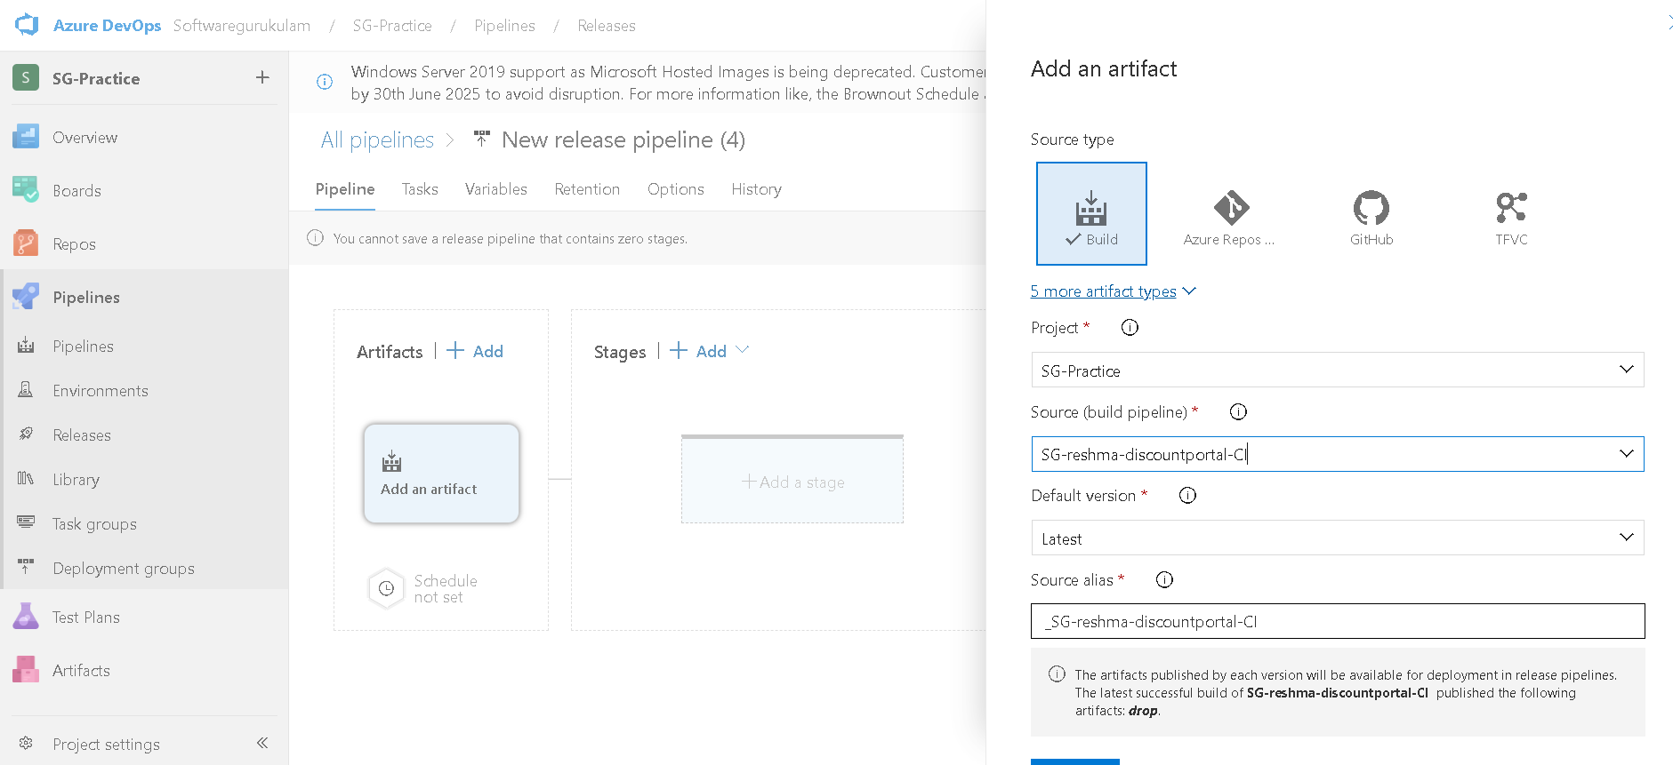

- Add a stages.
- Add IIS website deployment.

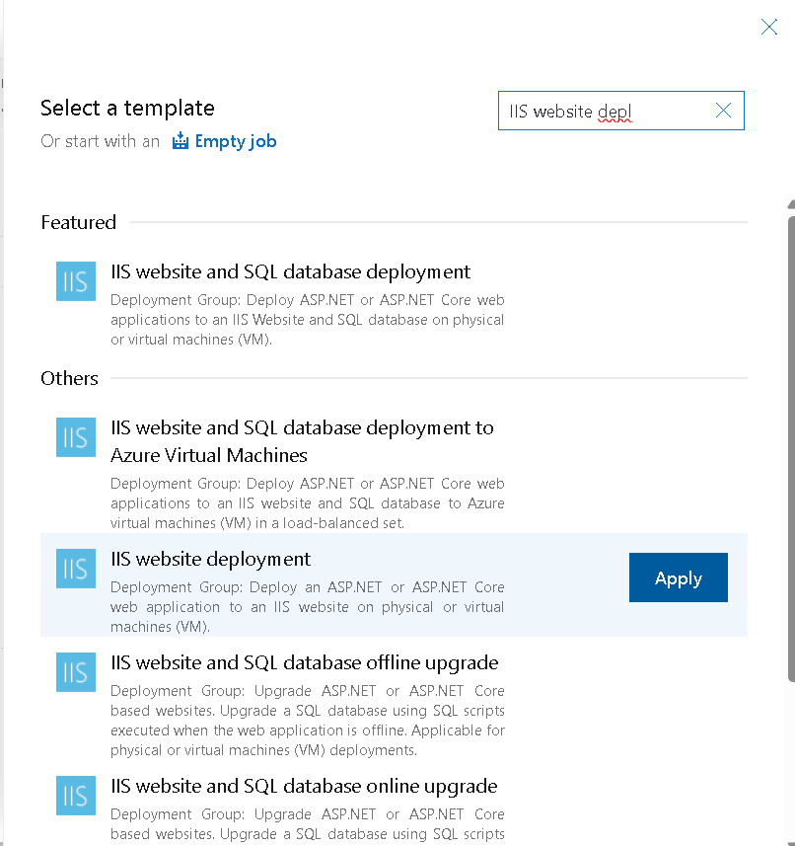

- The artifacts and the stage with 1 job and 2 task
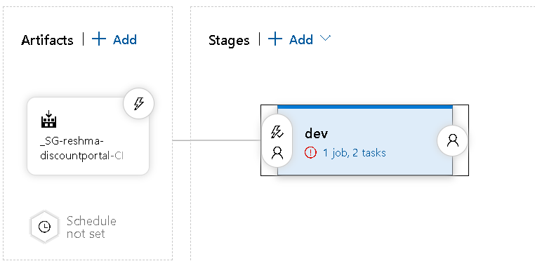

Step 4:
- IIS deployment-->Deployment group-->select your group.

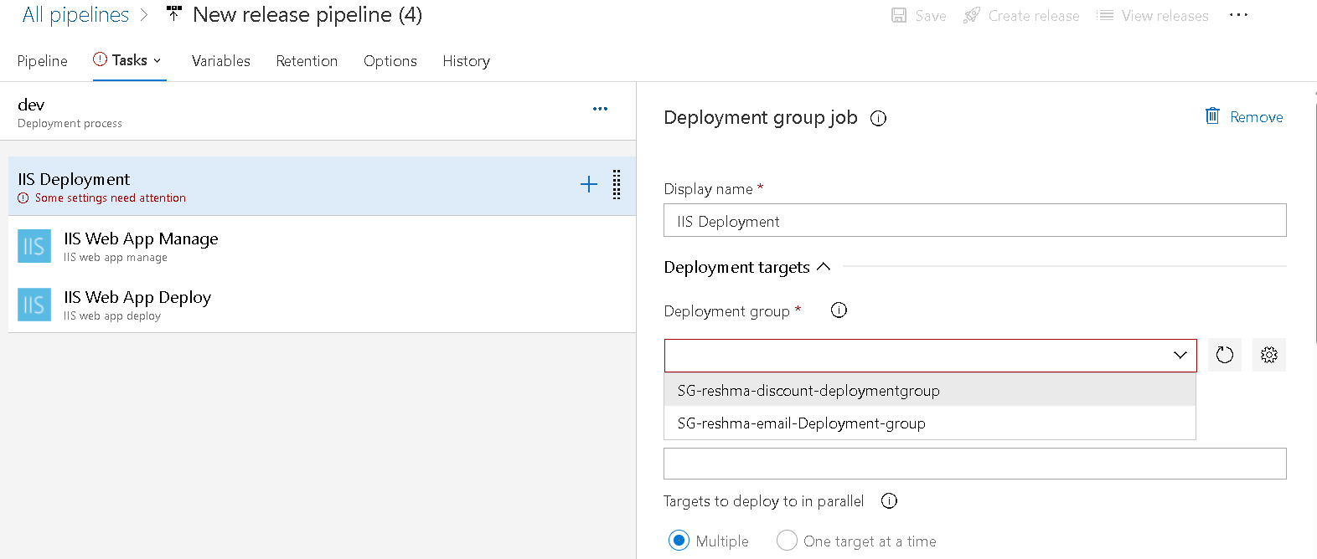

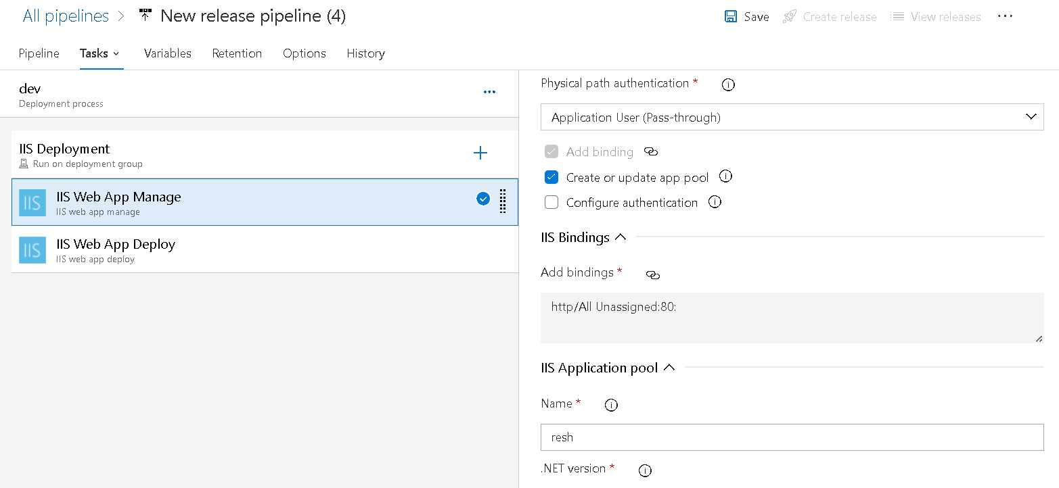

Step 5: Final step save and create release.

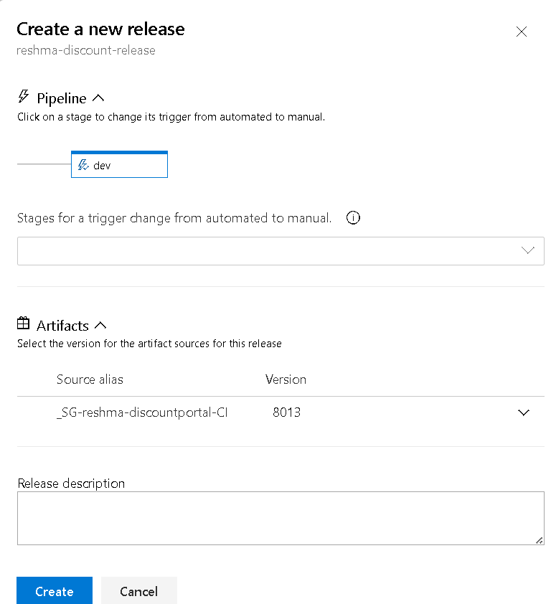

Released successfully

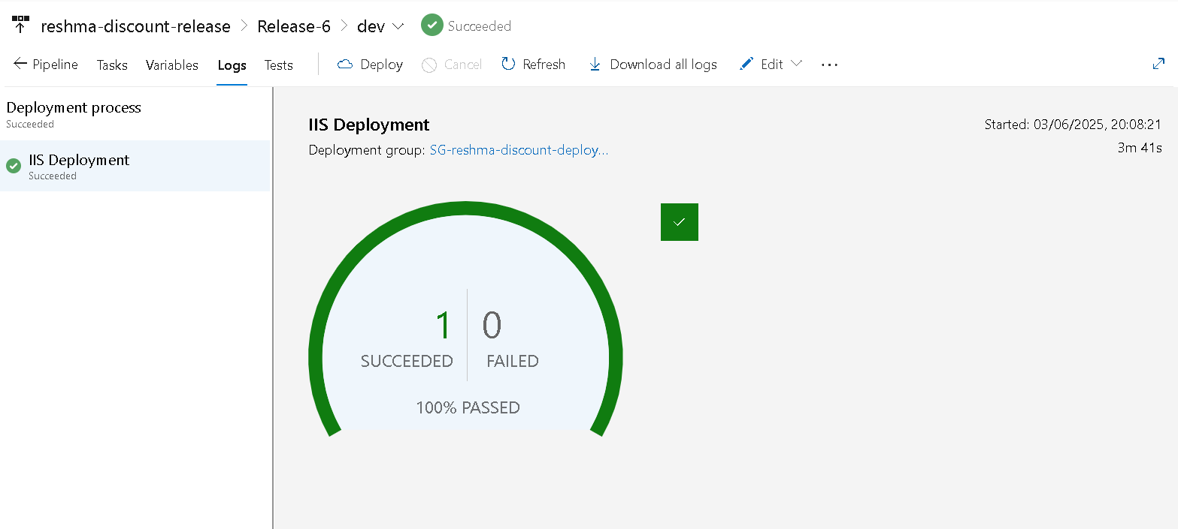

- You need to access it from the host/local machine.

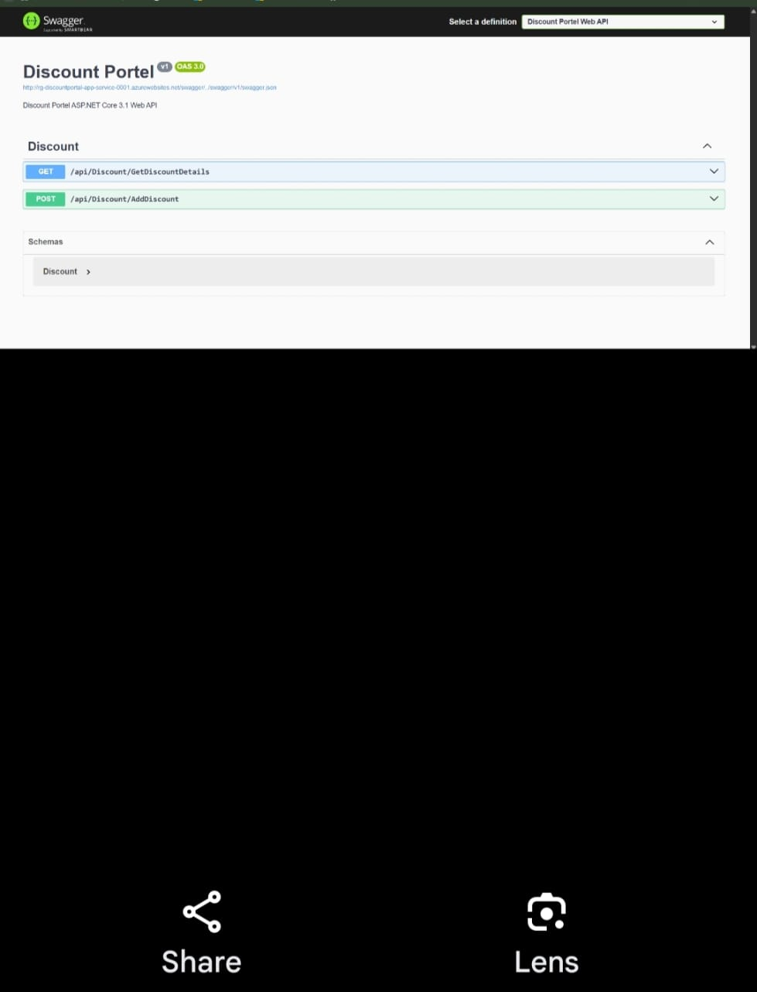

Process to Deploy a .NET App to PaaS using Azure DevOps
- Your application is already built using a CI pipeline (build artifacts are published)
- An Azure App Service is created in your Azure portal
- You have an Azure Service Connection in Azure DevOps (used to authenticate with Azure)
- In release we have two types by creating infrastructure with help of terraform and deploying the artifacts.

Step-by-Step: Creating Infra-structure using Terraform
Step 1: Modifying the code in the terraform file
- The block terraform { backend "azurerm" {} } defines where Terraform stores its state.
- You must configure it fully for Terraform to work with Azure Storage.
- After changing it, always run terraform init or terraform init -reconfigure.
- Create a pipeline on this terraform modification and artifacts the .tf file.

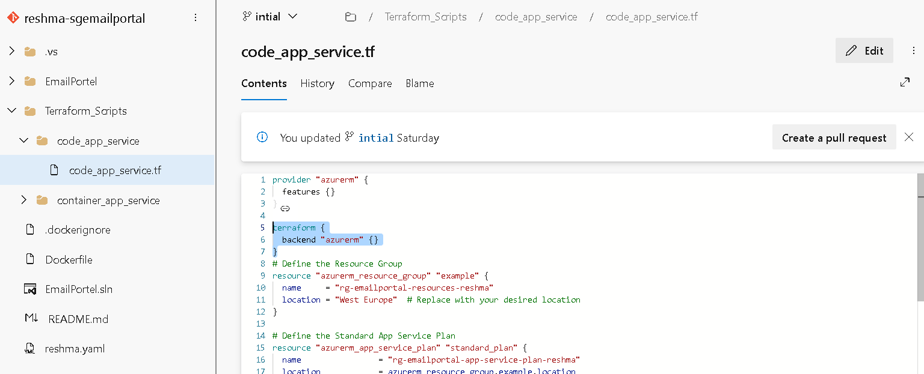

Step 2: Create Release Pipeline
      - Go to Pipelines > Releases
      - Click New Pipeline
      - Choose "Empty Job" for the Stage (e.g., name it Dev, QA, Prod)
      - Click Add an artifact:
      - Select your CI pipeline
      - Click Add
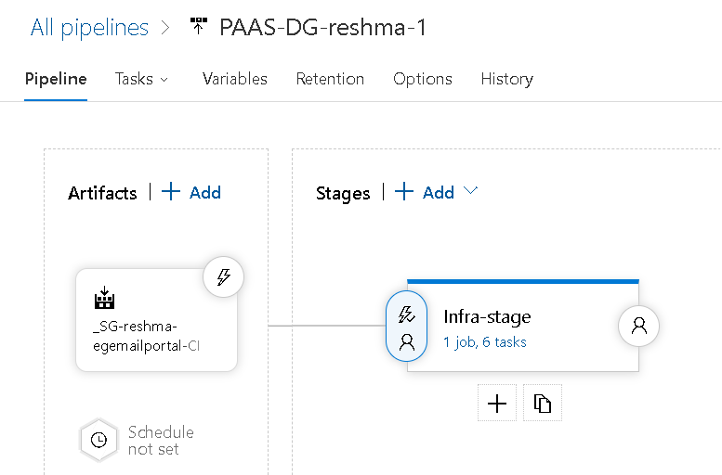

Step 3:
- In task,Add the Terraform Tool Installer
- And apply terraform for 5 times which are used for init,validate,plan,apply and destory
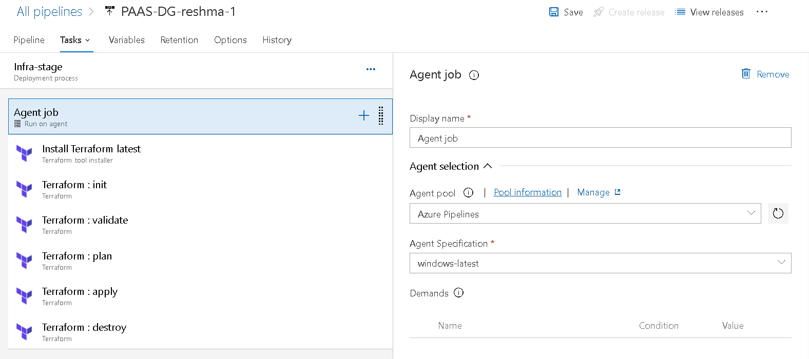

Step 4:
- In every task add the Configuration directory path.
- Connect with the service connection.
- Give the resource group,strorage account,container names that we have created in the Microsoft azure.
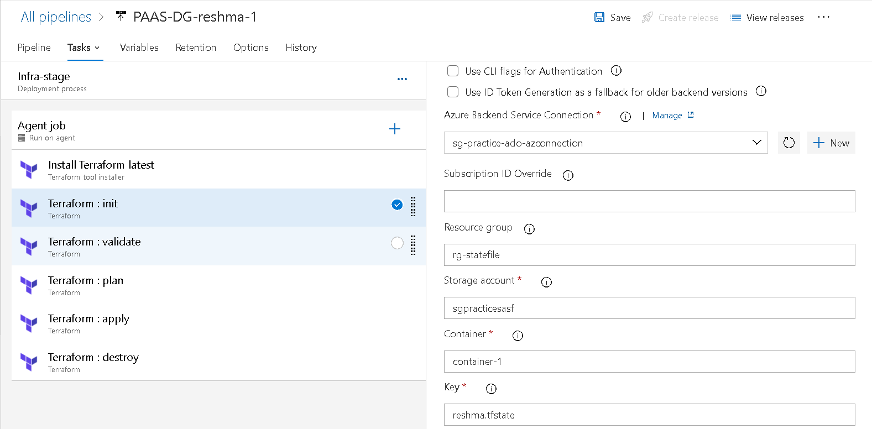

Step 5: Save and release the pipeline.

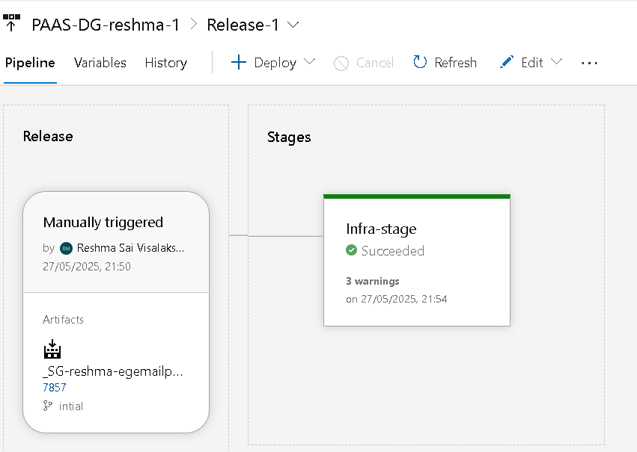

Deploying the artifacts:
Step 1:
- At stage add another stage name it as a Dev.
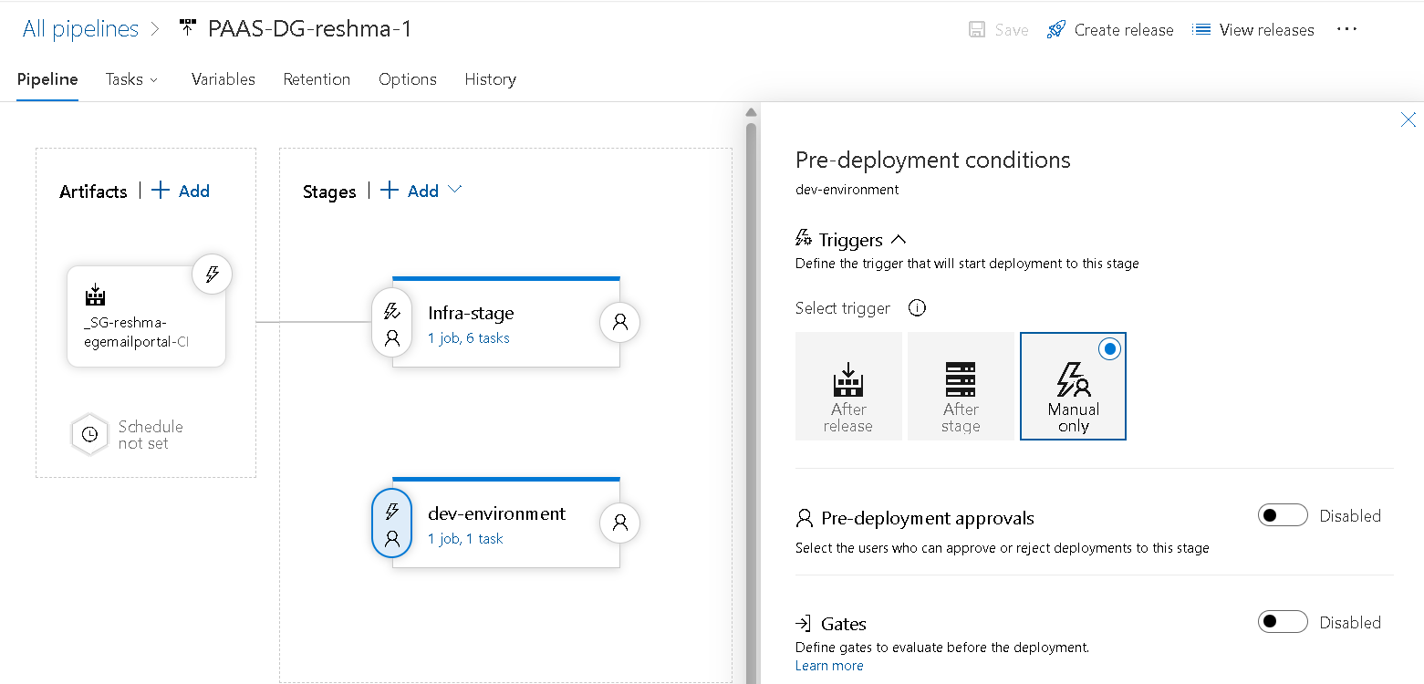
Step 2:
- Apply Azure App service Deploy to the dev stage.
- Add app service name that we have in our terraform code.

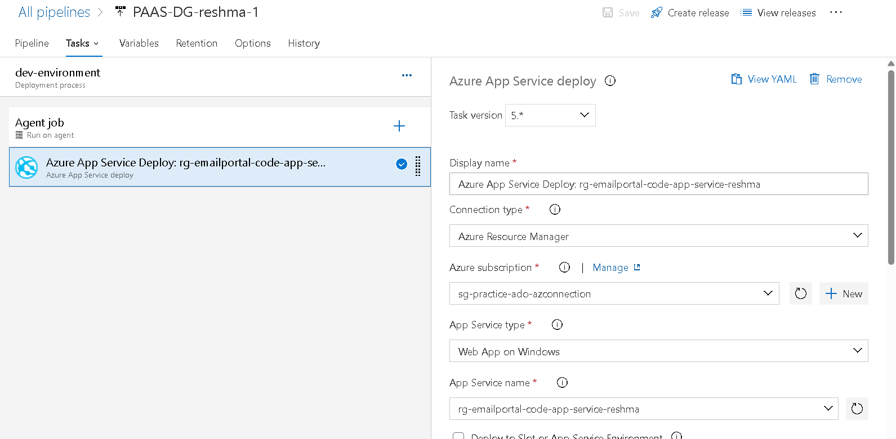

Step 3: Save and release the pipeline.

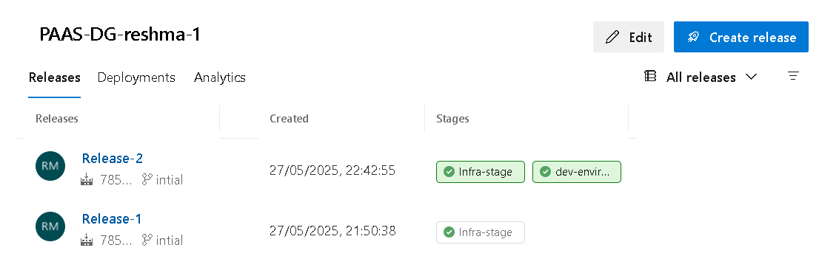
- Pipeline successfully released.

Step 4: Dev-environment--->view detailed logs--->follow the URLof azure app service.

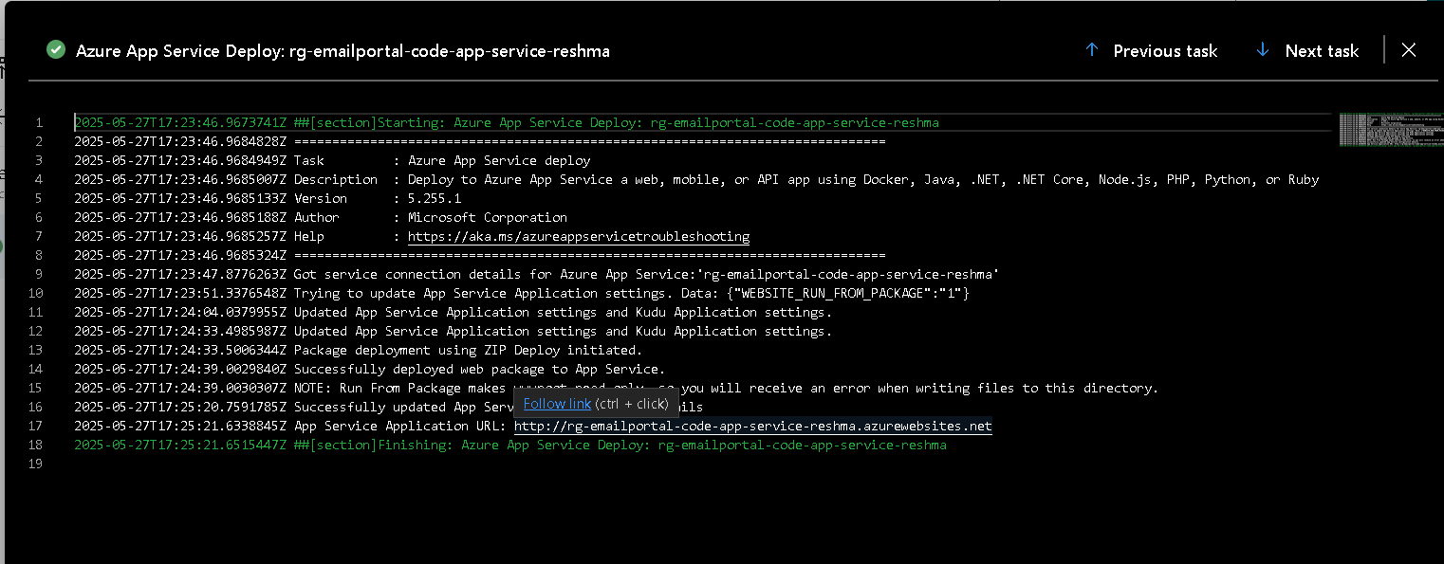

Final Output:

